**DEPARTMENT OF**

**SCHOOL OF COMPUTING**

**College of Engineering and Technology**

**SRM Institute of Science and Technology**

MINI PROJECT REPORT

ODD Semester, 2023-2024

Lab code & Sub Name : 21CSS201T & Computer Organization and Architecture

Year & Semester : II & 3rd

Project Title : Measuring distance with Arduino using an Ultrasonic Sensor module

Lab Supervisor  **: DR. Rajaram.V**

Team Members : 1. Muhammed Fayaaz (Reg.No:RA2211030010010)

2.Yogesh K R (Reg.No:RA2211030010064)

3.AustinPowersNewton (Reg.No:RA2211030010057)

|  |  |  |
| --- | --- | --- |
| **Particulars** | **Max. Marks** | Marks Obtained |
| **Name:** |
| **Register No:** |
| Program and Execution | 20 |  |
| Demo verification &viva | 15 |  |
| Project Report | 05 |  |
| **Total** | **40** |  |

**Date :**

**Staff Name :**

**Signature :**

Measuring distance with Arduino using an Ultrasonic Sensor module

**OBJECTIVE:**

**The objective of this mini project is to create a distance measurement system using an Arduino microcontroller and an ultrasonic sensor module. We aim to measure distances within a defined range, typically 2 cm to 200 cm, with precision and real-time feedback. By implementing the fundamental principles of ultrasonic distance sensing, including pulse generation, signal propagation, and echo reception, we intend to offer an affordable and versatile solution for applications like obstacle avoidance, robotics, and automation. The project will be comprehensively documented, encompassing hardware setup, Arduino code, and an accessible user interface for distance data visualization. Practical experiments will be conducted to demonstrate the system's reliability and precision, with a focus on promoting electronic, programming, and sensor integration knowledge among students and hobbyists. This project also encourages further customization and exploration, potentially leading to enhancements or specialized applications in specific domains.**

**ABSTRACT:**

**This mini project focuses on creating a distance measurement system using Arduino and an ultrasonic sensor module. Our goal is to measure distances accurately within a 2 cm to 200 cm range and provide real-time feedback. By implementing ultrasonic sensing principles, we offer an affordable solution for applications like obstacle avoidance and robotics. We will document the hardware setup, code, and a user-friendly interface. Practical experiments will demonstrate system reliability and precision, promoting knowledge in electronics and programming. This project encourages customization and exploration for potential enhancements and specialized applications.**

**INTRODUCTION:**

**The project introduces a versatile and cost-effective solution for distance measurement utilizing Arduino and an ultrasonic sensor module. It addresses the need for precise distance monitoring, which is crucial in various applications, including robotics and obstacle avoidance. By harnessing ultrasonic principles, this project offers an accessible platform for students and hobbyists to explore electronics, programming, and sensor integration. The project aims to not only document the development of this system but also to encourage further customization and potential applications in specialized domains. This introduction sets the stage for a compact, practical, and educational venture into distance measurement technology.**

**HARDWARE / SOFTWARE REQUIRED:**

**1.Arduino Microcontroller**

**2.Ultrasonic Sensor Module**

**3.Breadboard and Jumper Wires**

**4.Display**

**5.Power Supply**

**6.Arduino IDE**

**7.Arduino Libraries**

**8.Data visualization tools**

**9.Documentation tools**

**CONCEPT / WORKING PRINCIPLE:**

**1.Initialization (step A): The Arduino initializes the ultrasonic sensor module and sets up the necessary pins and components for operation.**

**2.Trigger Pulse (step B): The Arduino sends a trigger pulse to the ultrasonic sensor. This pulse is a short burst of high-frequency sound waves, typically at around 40 kHz.**

**3.Transmitting Ultrasound (step C): The sensor's transmitter emits the trigger pulse in the form of an ultrasonic sound wave. This wave propagates through the air toward the target object.**

**4.Obstacle Encounter (step D): When the sound wave encounters an obstacle or a surface, it reflects off that object.**

**5.Echo Reception (step E): The sensor's receiver, which is in listening mode, captures the reflected sound wave, also known as an echo.**

**6.Time Measurement (step F): The Arduino records the time elapsed between sending the trigger pulse and receiving the echo. This time measurement is typically in microseconds (µs).**

**7.Distance Calculation (step G): Using the speed of sound in air, which is approximately 343 meters per second (or 0.0343 centimeters per microsecond), the Arduino calculates the distance to the obstacle:**

**Distance (in centimeters) = (Time (in microseconds) / 2) × 0.0343**

**8.Data Display (step H): The calculated distance is then typically displayed on an LCD screen or other output device, providing real-time feedback to the user.**

**9.Continuous Operation (step I): The Arduino continuously repeats this process, sending trigger pulses, measuring echo times, and updating the displayed distance. This real-time operation allows the system to continuously monitor changes in distance, making it useful for applications like obstacle avoidance or tracking.**

**APPROACH/METHODOLOGY/PROGRAMS:**

**#include <LiquidCrystal.h>**

**LiquidCrystal lcd (10,9,5,4,3,2);**

**const int trigPin = 11;**

**const int echoPin = 12;**

**long duration;**

**int distance;**

**void setup () {**

**// put your setup code here, to run once:**

**analogWrite(6,100);**

**lcd.begin(16,2);**

**pinMode(trigPin, OUTPUT); // Sets the trigPin as an Output**

**pinMode(echoPin, INPUT); // Sets the echoPin as an Input**

**Serial.begin(9600); // Starts the serial communication**

**}**

**void loop () {**

**long duration, distance;**

**digitalWrite(trigPin,HIGH);**

**delayMicroseconds(1000);**

**digitalWrite(trigPin, LOW);**

**duration=pulseIn(echoPin, HIGH);**

**distance =(duration/2)/29.1;**

**Serial.print(distance);**

**Serial.println("CM");**

**delay (10);**

**// Prints the distance on the Serial Monitor**

**Serial.print("Distance: ");**

**Serial.println(distance);**

**lcd.clear();**

**lcd.setCursor(0,0);**

**lcd.print("Distance = ");**

**lcd.setCursor(11,0);**

**lcd.print(distance);**

**lcd.setCursor(14,0);**

**lcd.print("CM");**

**delay (500);}**

**FLOWCHART:**

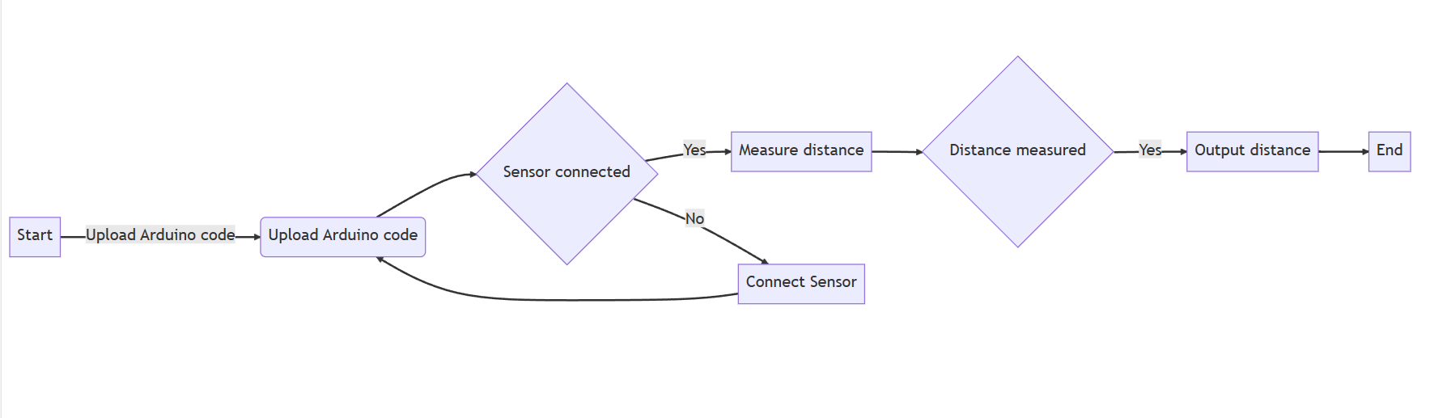

**OUTPUT:**

**CONCLUSION:**

**In conclusion, this mini project successfully demonstrated the practical application of an Arduino-based ultrasonic sensor system for precise distance measurement. By harnessing the principles of ultrasonic technology, the project provided real-time distance feedback, enhancing its utility in various fields, including robotics and automation. The integration of an LCD screen for visualizing measurements added user-friendliness. This project not only improved our understanding of electronics and programming but also highlighted the versatility and affordability of such distance measurement systems. Moreover, it serves as a steppingstone for further customization and specialized applications in specific domains, fostering creativity and exploration in the realm of sensor-based technology.**